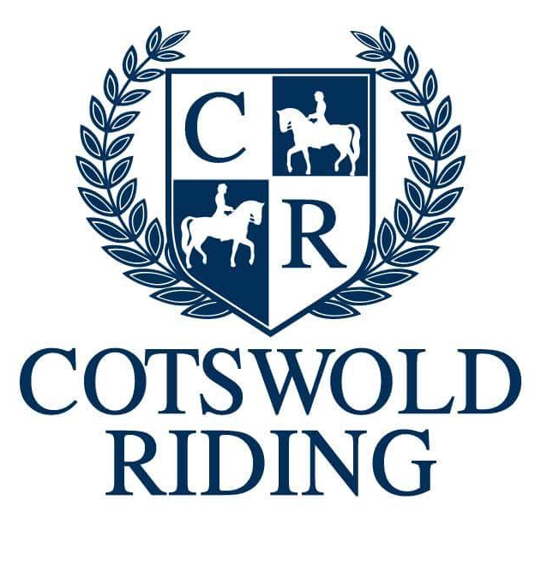

Name …………………………………………………………………………………….

Task
Research the following riders, finding out as much information about them as you can. For example:
How many horses do they have?
Have they been to the Olympics?
What is their discipline? (show jumping, Dressage or Eventing)

Rider | Information
William Fox-Pitt
Mary King
Oliver Townend
Ben Hobday
Zara Phillips
Charlotte Dujardin
Carl Hester
John Whitaker
Michael Whitaker
Pippa Funnell
Piggy French
Harry Charles
Nick Skelton
Scott Brash
Ben Maher
Michael Jung
Billy Twomey
Isabell Werth
Gareth Hughes
Princess Anne

