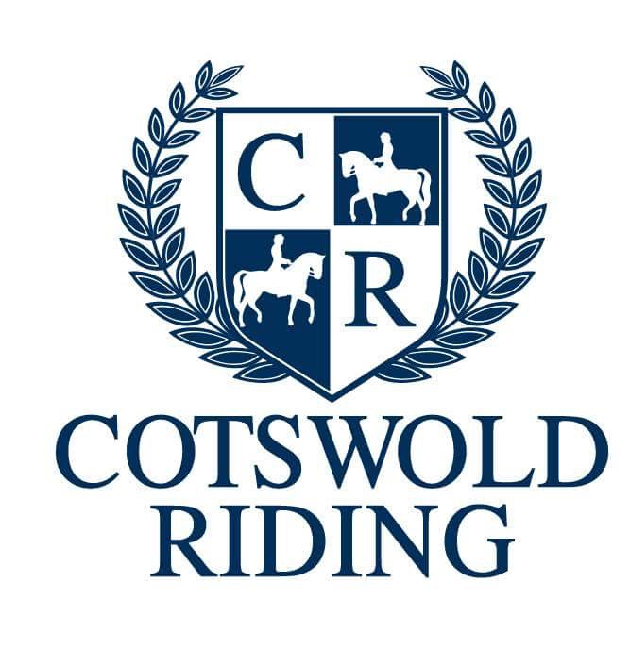

Can you unscramble the letters to work out the horse related words?

SROEH
OMROGGNI
NLGNUIG
LEDSAD
LBDEIR
KENE LORL
GOLN NERI
HRIGHT
HANMUN
WROB DNAB
IHWP
ANERA
PRURSTIS
GRTIH PSATSR
TLEMHE
NIOLASTL
YDOB RTRTPECOO
NGGDIEL
NKIGACH
LYFIL
ITB
ARME
EGSASRED
DEDBNIG
WHOS GMNJUIP
PUJM WGSIN
SORCS YTRUNCO
SEPOL
ENTGNEIV
YNPO BLCU
MKCINUG TUO
TETSEOR

